  Incorporating Qualifiers for  The Pony Club Spring Festival |   West Kype Farm, Strathaven ML10 6PR | 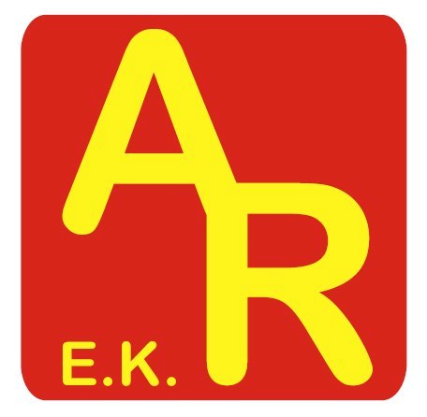  ROSETTES & PRIZES  SUPPORTED BY  ADVANCED ROLLER DOORS LTD  EAST KILBRIDE
ARENA EVENT
SUNDAY 11th OCTOBER 2026
CLASS | HEIGHT | DETAILS
Class 1 | 60cm | Open
Class 2 | 70cm | Open incorporates PC qualifier
Class 3 | 70cm | BE ACE & ACE Scotland qualifier
Class 4 | 80cm | Open incorporates PC qualifier
Class 5 | 80cm | BE ACE & ACE Scotland qualifier
Class 6 | 90cm | Open incorporates PC qualifier
Class 7 | 90cm | BE ACE & ACE Scotland qualifier
Class 8 | 1m | Open incorporates PC qualifier
Class 9 | 1m | BE ACE & ACE Scotland qualifier
Although British Eventing ACE Series qualification sees age groups compete together.
FORMAT  • Optimal time will be set at speed of 325mpm and riders penalised for being over or under.  • The competition will be run over a course of show jumping fences / working hunter / cross country.  • The course will be in the indoor school.  • Times will be allocated for each class.  • Total entries are limited so entries will close if capacity is reached ahead of the closing date. | ENTRY DEADLINES & FEES  Entry fees  £20 per class + £2 medical cover  WKRC members £18  Closing date  Thursday 8/10/26, 12 noon  or at capacity for event  Times  Will be posted on the website
Run under BE rules, scoring will be per Arena Events with an optimum time set at 325mpm.
XC attire to be worn, body protectors & skull caps

Secretary: Linda Anderson, West Kype Farm, Strathaven, ML10 6PR
Treasurer: Gillian Beattie, 14 Glassford Road, Strathaven, ML10 6LL

